Problem 4.3
a)
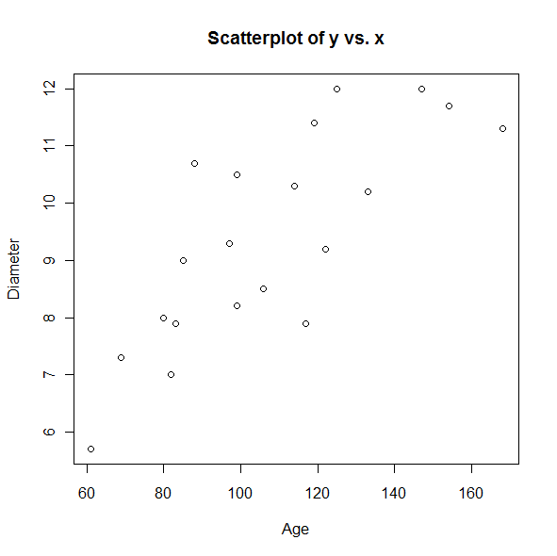

(d)
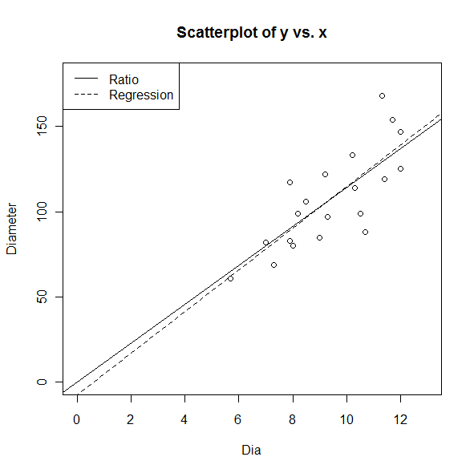
By looking at the plot, use either estimation would not make a big difference because both models give the data similar fits.
4.11
(a)
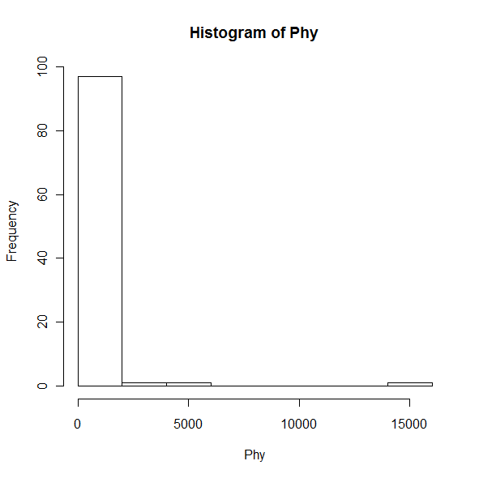
(b)

(c)
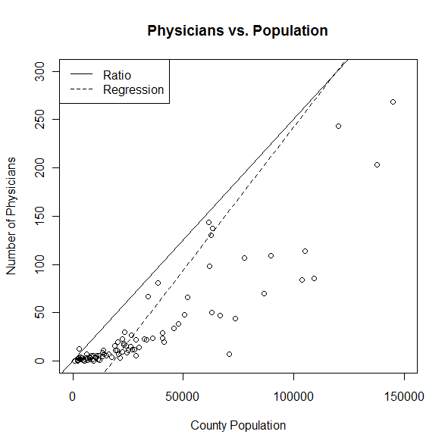
After throwing out the outliers, it is still hard to tell which method to use in this case. Since the regression model describes more of the data, I decied to use the regression model.
(d)

(e) The regression estimate method comes closer since the total esitmated number of physicians in the US is 639,506 using the ratio method, which is much high than the regression estimate and the acutal total.
4.36
(a)
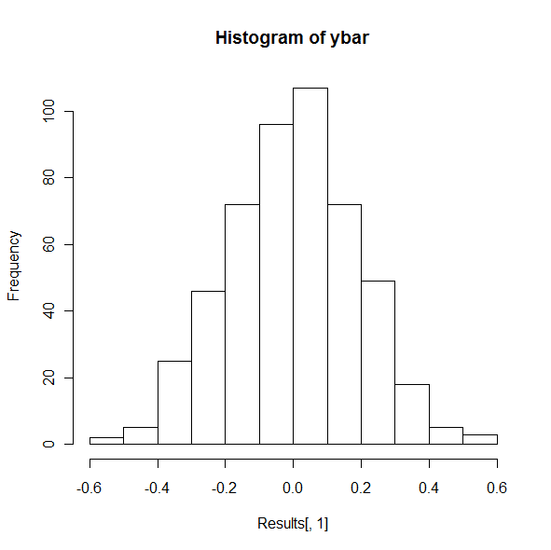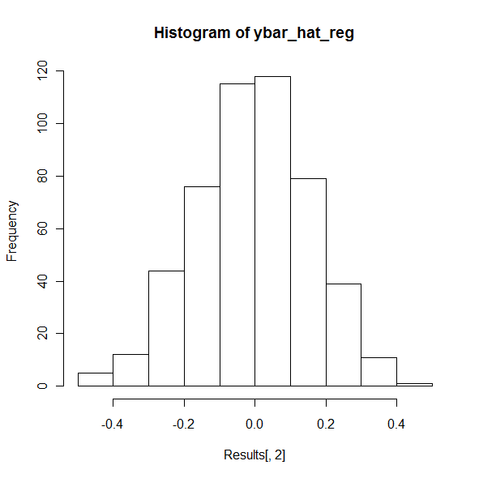
Both histograms show a bell shape distribution of the data, and the histogram for y̅ is more spread out, indicating that it has a larger variance.
(b)
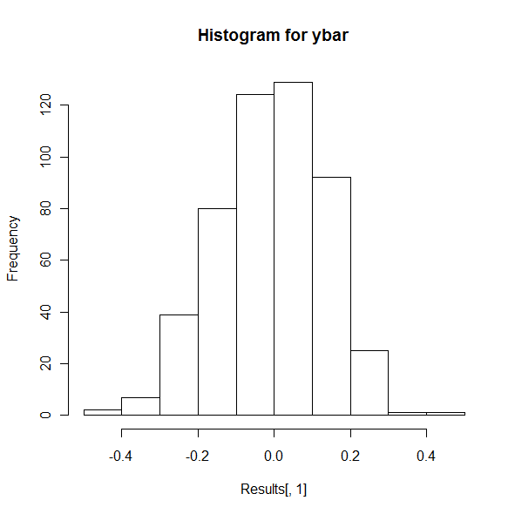
Again, both histograms show a bell shape distribution of the data. This time there is not obvious difference in their variances, which tells that a larger sample size would reduce variance.

